TITLE OF THE PAPER

Abstract:
Papers should be submitted in camera–ready form on 6 (six) or 8 (eight) A4 page. Please do not submit papers with more than 8 or less than 6 A4 pages. The manuscript will be reproduced full size from your copy. So, please write your paper directly in this template. The abstract portion is a narrative presentation without references, and should have 200-250 words.
Key words: List 5-6 keywords. Key words should not repeat the title of the paper.

- Introduction

2. GENERAL information
2.1 Layout
Please prepare your camera–ready paper in full–size format, on A4 (metric) paper (29.7 cm x 21 cm). Papers should comprise 6 (six) or 8 (eight) A4 unnumbered pages and should be sent (the Word) by e-mail using the provided submission instructions. Please do not submit papers with more than 8 or less than 6 A4 pages and no more than 6 figures.
Margins: top, bottom-20 mm each, right and left -20 mm each. The paper should be written in plain English.
Please use Arial fonts, line spacing single.
The font formats are:

Table 1
TABLE TITLE
Type size | Use for
9 | Author’s affiliations, references
10 | Table captions, corresponding author, abstract, keywords, tables, figure captions
11 | Main text, Equations, Section subtitles, subheadings
12 | Author names, Chapter titles

3. FIGURES AND TABLES
3.1. Figures
The figures have to be made in high quality, which is suitable for reproduction and print.
Figure captions should be below the figures, centered. Use the abbreviation Fig. 1 even at the beginning of a sentence.
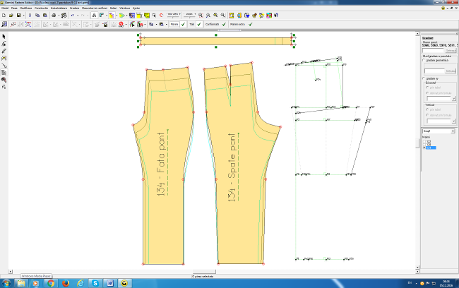
Fig. 1. The basic pattern for trousers boys aged 6-8 years

3.2. Tables
Each table is numbered and table captions are in ARIAL 10 pt, placed above the table.

4. EQUATIONS
Equations are left justified 5 mm from left with equation number at the right margin in font ARIAL 11 pt Italic.

$R_{a}=\text{ 0,65}⋅R_{\text{max}}^{\text{0,9}}$ (1)

5. ConclusionS
Summarize the conclusions of the paper in a simple, straightforward way. Emphasize the original contribution of the authors.
Please read carefully these instructions for authors. Papers delivered in incorrect form, will not be published in the proceedings.
Please read the guidelines then visit the Journal’s submission site manuscriptmanager.net/it or the button Submit manuscript to upload your manuscript. Please note that manuscripts not conforming to these guidelines may be returned.

ACKNOLEDGEMENTS

REFERENCES

Citations in text should be made with Arab numerals in square brackets [1-3]. References should be presented in consecutive order (as they are referred to in the text) at the end of the paper, after one clear line in ARIAL 9 pts [4]. Please include at least 6 items [5]. References will be given in the original language [6]. Publications by the same author(s) should be listed in order of year of publication [7]. Please take into consideration that all references listed here is compulsory to be directly cited in the body of the text [8]. Please don’t use the own quotations.

[1] Hong, Y., Bruniaux, P., Zhang, J., Liu, K., Dong, M., Chen, Y., Application of 3D-to-2D garment design for atypical
morphology: a design case for physically disabled people with scoliosis, In: Industria Textila, 2018, 69, 1, 59–64, http://doi.org/10.35530/IT.069.01.1377
[2] Žunič Lojen, D., Jevšnik, S., Some Aspects of Fabric Drape, In: Fibres & Textiles in Eastern Europe, 2007, 15, 4, 39-45
[3] Rudolf, A., Stjepanovič, Z., Cupar, A., Designing the functional garments for people with physical disabilitiesor
kyphosis by using computer simulation techniques, In: Industria Textila, 2019, 70, 2, 182–191, http://doi.org/10.35530/IT.070.02.1592
[4] Žunič Lojen D., Jevšnik S., Some Aspects of Fabric Drape, In: Fibres & Textiles in Eastern Europe, 2007, 15, 4, 39-55
[5] Cusick, G.E., A study of Fabric Drape, In: Faculty of Technology, University of Manchester, 1962
[6] Robson, D., Long, C.C., Drape Analysis using Imaging Techniques, In: Clothing and Textiles Research Journal 2000, 18, 1, 1-8
[7] Kenkare, N., May-Plumlee, T., Fabric Drape Measurement: A Modified Method Using Digital Image Processing, In: Journal of Textile and Apparel, 2005, 4, 3, 1-8
[8] Szabo, L., Halasz, M., Examination of dependence of drape coefficient on the samples size, In: Tekstil, 2008, 57, 9, 439 – 447
[9] Nofitoska, M., Demboski, G., Carvalho, M.A.F., Effect of fabric structure variation on garment aesthetic properties, In: Tekstil ve Konfeksiyon, 2012, 22, 2, 132-136
[10] Šarac, T., Stepanović, J., Demboski, G., Petrović, V., Fabric draping and cotton fabric structure relation analysis, In: Advanced Technologies, 2015, 4, 1, 84-88
[11] SRPS F.S2.016 Tekstil - Metražna roba - Određivanje mase po jedinici dužine i jedinici površine, 1986
[12] BS EN 12127 Textiles. Fabrics. Determination of mass per unit area using small samples, 1998
[13] SRPS ISO 7211-5 Tekstil - Tkanine - Konstrukcija - Metode analiza - Deo 5: Određivanje linearne gustine pređe iz tkanine, 2005
[14] DIN 53830-3Prüfung von Textilien - Bestimmung der Feinheit von Garnen und Zwirnen - Einfache Garne und Zwirne, texturierte Garne - Abschnittverfahren,1981

